Role of the masterpiece “The Divine Comedy” in the growth of the Italian language
Dante Alighieri,¹ Beatrice Portinari,¹ and P. Virgilio Marone²
¹Department of Italian Poetry, University of Firenze, Firenze, Italy; ²Department of Latin Language, University of Rome, Rome, Italy.

Midway along the journey of our life I woke to find myself in a dark wood (Figure 1), for I had wandered off from the straight path. How hard it is to tell what it was like, this wood of wilderness, savage and stubborn (the thought of it brings back all my old fears), a bitter place! Death could scarce be bitterer. But if I would show the good that came of it I must talk about things other than good.

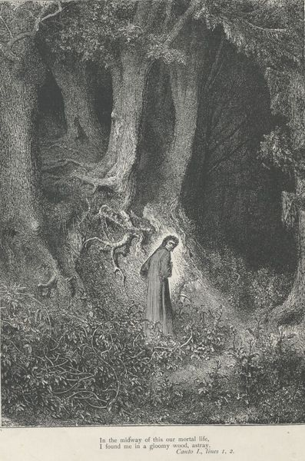

How I entered there I cannot truly say, I had become so sleepy at the moment when I first strayed, leaving the path of truth; but when I found myself at the foot of a hill, at the edge of the wood’s beginning, down in the valley, where I first felt my heart plunged deep in fear, I raised my head and saw the hilltop shawled in morning rays of light sent from the planet that leads men straight ahead on every road. And then only did terror start subsiding in my heart’s lake, which rose to heights of fear that night I spent in deepest desperation.
Just as a swimmer, still with painting breath, now safe upon the shore, out of the deep, might turn for one last look at the dangerous waters, so I, although my mind was turned to flee, turned round to gaze once more upon the pass that never let a living soul escape.
I rested my tired body there awhile and then began to climb the barren slope (I dragged my stronger foot and limped along) [1].
[1] Alighieri, D. The Divine Comedy, 1308, 1, 1-2.

